

V 1.0
May 2026
XStep Design Specification
SMPL: PCV Measurement

Table of Contents
Right-click and choose Update Field to build the table of contents.

Purpose
This document outlines the functional and technical design, along with the configuration specifications for the XStep “SMPL: PCV Measurement”. It provides the necessary framework for calculating the average Packed Cell Volume (PCV) to determine the discharge interval.

Overview
The "SMPL: PCV Measurement" XStep allows operators to dynamically record, calculate, and verify Packed Cell Volume percentages across multiple sample replicates.
The XStep contains several main input parameters:
- IV_HEADER - This can be changed in SiMPL MBR to display specific header text for the XStep
- IV_INSTR - This can be changed in SiMPL MBR to display a specific set of instructions for the XStep that will be displayed below the header

The following fields are auto populated in the Xstep:
- “No.” - Output numeric field which auto-populates sequentially with each add table line. The first output value is “1”
- The table rows should be limited to two table rows.

The operator inputs the following field:
- “Dilution factor” - Input Text

The operator inputs the following fields in the table:
- “PCV Result 1” - Input Numeric
- “PCV Result 2” - Input Numeric
- “PCV Result 3” - Input Numeric

The operator selects from the dropdown measurement whether a total sample volume of 40µL or 25µL will be used for the subsequent calculation.
- “Total Sample Volume (µL)” - Dropdown Input

The % PCV Result is calculated the same for all three values based on the selected total sample volume.
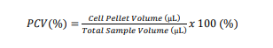
- “%PCV Result 1” - Output Numeric
- “%PCV Result 2” - Output Numeric
- “%PCV Result 3” - Output Numeric

The sum of %PCV Results is calculated by adding all three %PCV values together
- “Sum of %PCV Results” - Output Numeric

The Average PCV is calculated by dividing the Sum of % PCV Results by 3:
- “Average PCV” - Output Numeric

Functional Design
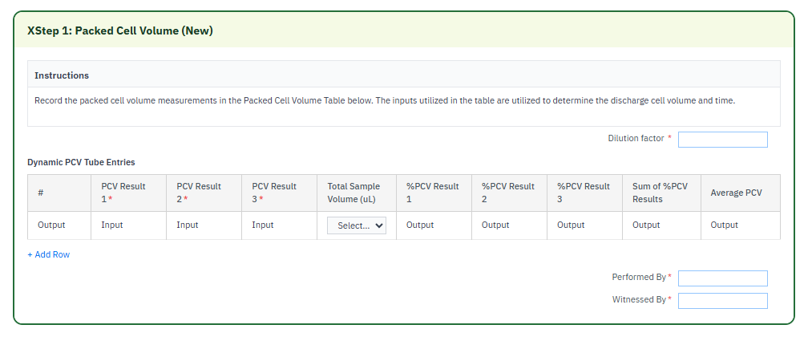

Reasons for developing
The implementation of the SMPL: PCV Measurement XStep is required to transition manual, paper-based Packed Cell Volume tracking into a fully compliant, automated electronic workflow. PCV is a critical process parameter (CPP) directly linked to biomass estimation and downstream yield optimization. By integrating this step into the SiMPL EBR framework, the system eliminates human error related to manual math equations, guarantees that sample processing remains strictly bounded to a maximum of two key samples, and enforces dual-signature GMP accountability. This ensures data integrity, minimizes deviations on the manufacturing floor, and accelerates batch release cycles.

Authorization
The Signature Strategies SS000201 - SiMPL Done By and SS000202 - SiMPL Checked By are created and assigned to the Authorization Groups AGDS0001 PI step Done By SS and AGDS0002 PI step Checked By SS. This ensures that at least two users are required to successfully sign off the process step. The first user signs off in the Performed By field and a second user signs the Witnessed By field.

Assumptions/ Dependencies
 | Assumption
1 | User signing signature fields is an approved user in the system with the correct access configuration
2 | Master Data has been set up correctly
3 | The function modules return the correct calculation output values.
4 | The function module can successfully pull the data into the output fields

Validation Checks
Error Handling
Error | Action
User Signature rejected due to an incorrect username or password | User accepts error message and re-enter the correct username and password
Mandatory field data not captured | A validation error is displayed - capture mandatory fields.
Calculation incorrect. | Verify function modules.

XStep Layout Design
*EBR screenshot will be added once development and testing have been completed.

Function Module(s)
Function: /SMPL/PPPI_FM_CALC_EXECUTE
Import Parameters:
Parameter Name | Associated Type | Short Text
IV_VAL1 | F | Floating point (value 1)
IV_TYPE1 | CHAR1 | Character 1 (operation 1)
IV_VAL2 | F | Floating point (value 2)
IV_TYPE2 | I | Integer (operation 2)
IV_VAL3 | F | Floating point (value 3)
IV_RESULT_UOM | ERFME | Unit of measure of entry (result UOM)

Export Parameters:
Parameter Name | Associated Type | Short Text
EV_RESULT | F | Floating point (calculated result)
EV_RESULT_OUT | CHAR30 | Character 30 (formatted result)

Function: /SMPL/PPPI_FM_INITIAL_ACTIVE
Import Parameters:
Parameter Name | Associated Type | Short Text
IV_ACTIVE | CHAR1 | N/A

Export Parameters:
Parameter Name | Associated Type | Short Text
EV_ACTIVE | CHAR1 | N/A

Function: /SMPL/MBR_DEP_CHECK_ACTIVE
Import Parameters:
Parameter Name | Associated Type | Short Text
IM_CONTROL_RECIPE | POC_DOCID | N/A
IM_PHASE | VORNR
IM_AUFNR | AUFNR
IM_STEP_UUID | /SMPL/MBR_SOG_UUID
IM_PLANT | WERKS_D

Export Parameters:
Parameter Name | Associated Type | Short Text
EV_ACTIVE | CHAR1 | N/A

Exceptions:
Exception | Short Text
CONTROL_RECIPE_INITIAL

Pseudocode
Function: /SMPL/PPPI_FM_CALC_EXECUTE
1. Purpose
A generic two-step calculation engine for XStep formulas. It applies one arithmetic operation to two values and, optionally, a second operation with a third value, then formats the result with a unit of measure for display.
2. Input Parameters
• IV_VAL1 / IV_VAL2 – the first operands.
• IV_TYPE1 – the first operation (add, subtract, multiply, divide, or absolute-difference).
• IV_TYPE2 / IV_VAL3 – optional second operation and its operand, applied to the intermediate result.
• IV_RESULT_UOM – optional unit of measure used when formatting the output.
3. Export Parameters
• EV_RESULT – the numeric calculation result.
• EV_RESULT_OUT – the formatted result string (value with UOM).
4. Processing Logic
a. If IV_VAL1 > 0, apply the first operation (IV_TYPE1) to IV_VAL1 and IV_VAL2 — add, subtract, multiply, divide (guarding against divide-by-zero → 0), or absolute difference.
b. If a result was produced and IV_TYPE2 is supplied, apply the second operation with IV_VAL3 to the intermediate result (same operation set, same divide-by-zero guard).
c. Call /SMPL/PPPI_FM_OUTPUT_VALUE with the result and IV_RESULT_UOM to produce the formatted display string EV_RESULT_OUT.
Output
• EV_RESULT (numeric) and EV_RESULT_OUT (formatted with UOM).
Additional Notes
Error Handling:
• No exceptions; division by zero yields a result of 0.
Dependencies:
• Function module /SMPL/PPPI_FM_OUTPUT_VALUE; calculation-type constants (plus/minus/multiply/divide/abs-minus).
Assumptions:
• IV_VAL1 greater than zero indicates a calculation should be attempted; the operation-type codes match the configured calculation constants.

Function: /SMPL/PPPI_FM_INITIAL_ACTIVE
1. Initialization
a. Input parameter IV_ACTIVE is optionally provided by the calling logic.
b. Constants gc_yes, gc_no, and gc_inside_range are assumed to be defined globally in the context of the function module.
2. Active Flag Evaluation
a. The function checks if the input value IV_ACTIVE falls within the expected valid range, represented by gc_inside_range.
b. Based on the result:
• If the input value is not equal to gc_inside_range, the XStep is marked as inactive by setting EV_ACTIVE = gc_no.
• If the input value is equal to gc_inside_range, the XStep is marked as active by setting EV_ACTIVE = gc_yes.
3. Output Assignment
a. The evaluated result is returned in the EV_ACTIVE export parameter for use by the calling logic (e.g., XStep configuration, PI sheet rendering).
Additional Notes
• This is a simple normalization function that abstracts how activation flags are interpreted for PPPI XSteps.
• The use of constants (gc_yes, gc_no, gc_inside_range) aligns the logic with broader application settings or standards.
• Input is optional, so defaulting behavior can be configured outside this function.

Function: /SMPL/MBR_DEP_CHECK_ACTIVE
1. Initialization
a. Input parameters provide context for determining whether an MBR step can be activated:
• IM_CONTROL_RECIPE (POC_DOCID) – Control recipe ID identifying the batch instruction.
• IM_PHASE (VORNR) (Optional) – Operation or phase within the process order.
• IM_AUFNR (AUFNR) (Optional) – Process order number associated with the step.
• IM_STEP_UUID (/SMPL/MBR_SOG_UUID) – Unique step identifier (SOG).
• IM_PLANT (WERKS_D) – Plant code for process context.
b. The function validates that IM_CONTROL_RECIPE is not initial; if it is, CONTROL_RECIPE_INITIAL is raised. Internal data is initialized and routine LOAD_INTERNAL_DATA populates the order dependency buffers.
2. Signature Data Retrieval
a. Signature records for the process order are retrieved from /SMPL/MBR_OR_SIG (AUFNR = IM_AUFNR) into internal table lt_ord_sigs for evaluation.
3. Dependency Evaluation
a. The function loops through dependencies where TARGET_UUID = IM_STEP_UUID and DEP_RULE is a Perform-Before-Start or Verify-Before-Start rule:
• For PERFORM BEFORE START, it checks whether the prerequisite step has a pending perform signature.
• For VERIFY BEFORE START, it checks whether the prerequisite step has a pending verify signature.
b. If an incomplete signature is found, the step is marked inactive (EV_ACTIVE = gc_step_inactive); if all prerequisites are complete, it is marked active (EV_ACTIVE = gc_step_active).
4. Output Assignment
a. The evaluated activation status is returned in EV_ACTIVE (active = all prerequisites complete; inactive = at least one prerequisite incomplete).
Additional Notes
• Evaluates Perform Before Start and Verify Before Start dependency rules using live signature data from /SMPL/MBR_OR_SIG.
• Error Handling: raises CONTROL_RECIPE_INITIAL if the control recipe is missing; handles empty dependency/signature data without runtime errors.
• Activation status is recalculated each time the function is called to reflect live signature data.

Configuration Specification
N/A

Test Scenarios
# | Scenario | Expected Result | Actual Result | Pass/ Fail
1 | Create and Release a Process Order with the pre-configured SiMPL Master Recipe and the relevant Production Version | Process Order created and Released containing SMPL: PCV Measurement | Process Order created and Released containing SMPL: PCV Measurement
2 | Open the EBR, and navigate to SMPL: PCV Measurement | The EBR for the selected Process Order and Control Recipe opens successfully without any errors and the SMPL: PCV Measurement | The EBR for the selected Process Order and Control Recipe opens successfully without any errors and the SMPL: PCV Measurement
3 | The operator inputs the dilution factor. | Value accepted. | Value accepted.
4 | The operator inputs N/A as the dilution factor. | Text value accepted. | Text value accepted.
5 | The operator inputs the PCV Results for value 1-3 | Numeric values accepted | Numeric values accepted
6 | The operator selects the total sample volume from the dropdown input. | Subsequent calculations are correct based on dropdown selection. | Subsequent calculations are correct based on dropdown selection.
7 | Verify the %PCV Result values in the subsequent output fields. | Calculations are correct. | Calculations are correct.
8 | Verify sum of %PCV Results | Calculation correct | Calculation correct
9 | Verify average PCV value | Calculation correct | Calculation correct
10 | Add table line to record values for a second sample. | Second table row added but limited to two rows maximum. | Second table row added but limited to two rows maximum.
11 | Enter a username in the “Performed By” field then enter the password in the pop-up window. | Signature is accepted | Signature is accepted
12 | Enter a username in the “Witnessed By” field then enter the password in the pop-up window. | Signature is accepted | Signature is accepted

Document References
Reference No. | Document Title
Number used in superscript for reference | Full name of referenced document
1 | SiMPL Functional Guide: Universal Concepts

Revision History
Version No. | Description | Author | Date
1.1 | Initial Document (Functional requirements and Technical specification) | Frieda van der Merwe | 25-05-2026

